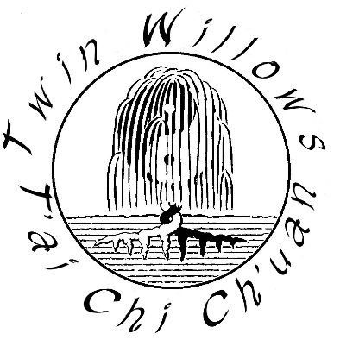
YANG STYLE T'AI-CHI CH'UAN
FAST FORM
1st Section
Beginning
Clear Right and Left
Active Step Ward Off Da
Active Step Ward Off Hua
Active Step Roll Back
Active Step Press
Active Step Push
Active Step Single Whip
Lift Hands
Shoulder
White Crane Spreads its Wings
Active Step Brush Knee
Play Guitar
Active Step Brush Knee
Turtle Hides Its Head
Elbow Strike
Chop with Fist
Active Step Deflect In, Parry and Punch
Active Step Withdraw and Push
Cross Hands

2nd Section
Embrace the Tiger to Return it to the Mountain
Roll Back
Press
Push
Diagonal Single Whip
Fist Under Elbow
Step Back, Repulse Monkey
Step Back, Repulse Monkey
Step Back, Repulse Monkey
Diagonal Flying
Cloud Hand
Cloud Hand
Cloud Hand
Single Whip
Squatting Single Whip
Golden Rooster
Golden Rooster
High Pat on Horse
Separate the Foot
Separate the Foot
Turn and Kick with Heel
Step Back Brush Knee
Needle at Sea Bottom
Fan Through Back
Turn and Chop with Fist
Parry and Chop
Downward Arm Bar
Deflect Up, Parry and Punch
Kick Upward
Strike Tiger
Strike Tiger
Golden Rooster
Twin Winds Pierce the Ears
Kick Upward
Wrap the Firecrackers
Deflect Down, Parry and Punch
Withdraw and Push
Cross Hands

3rd Section
Embrace the Tiger to Return it to the Mountain
Parting Wild Horses Mane
Parting Wild Horses Mane
Fair Lady
Fair Lady
Fair Lady
Fair Lady
Ward Off Da
Ward Off Hua
Roll Back
Press
Push
Single Whip
High Pat on Horse
Thrusting Hand
Turn and Cross Kick
Punch Downward
Change Step Active Step Ward Off Da
Active Step Roll Back
Active Step Press
Active Step Push
Single Whip
Squatting Single Whip
Step to Seven Stars
Retreat to Ride the Tiger with Kick
Inside Kick
Outside Kick
Bend the Bow to Shoot the Tiger
White Snake Spits Out Its Tongue
Active Step Deflect Out, Parry and Punch
Active Step Withdraw and Push
Conclusion

