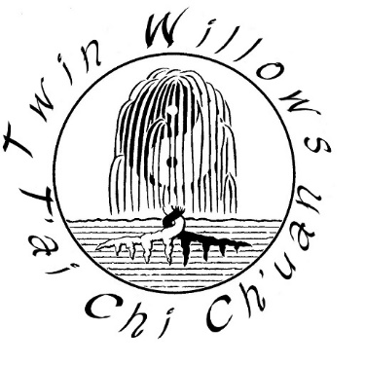
T’ai Chi Cane Form

Section 1
- Preparation
- Beginning
- Sweep Up and Kick
- Strike Laterally
- Left Intercept
- Front Ward Off
- Bind the Head and Twin Winds Lateral Strike
- Bind the Head, Hang Up, and Heavy Split Downward
- Turn the Body, Bind the Head, Hang Up and Heavy Split Downward
- Cross Behind, Deflect and Split
- Backward Turn Round the Body and Split Mt. Hua with Force
- Mickey Mouse Strike

Section 2
- Strike Upward
- Front Ward Off
- Bind the Head and Twin Winds Lateral Strike
- Bind the Head, Hang Up, and Heavy Split Downward
- Protect the Leg and Split
- Cross Behind, Left Stir Up and Reverse Split
- Left Stir Up and Heavy Split

Section 3
- Turn Left, Bind the Head, Leap and Twin Winds Lateral Strike
- Turn Right, Bind the Head, Leap and Strike Laterally
- Coiled Step and Trap
- Step Forward, Bind the Head, and Twin Winds Lateral Strike
- Withdraw Step and Split
- Left Stir Up and Split

Section 4
- Strike Obliquely, Left and Right
- Turn the Body, Strike Obliquely, Left and Right
- Left Turn, Downward Sweep, and Intercept
- Right Turn, Downward Sweep, and Intercept
- Left Strike, Cross Behind, and Reverse Split
- Left Stir Up and Heavy Split
- Strike Forward, Twist Cane and Strike
- Conclusion

